
Viewed by:
Guy SCRUIGNEC
Tel.: +33 (0)2 99 27 92 92
E-mail: guy.scruignec@iwedia.com

Written by:
Yannick PETITBOIS
Tel.: +33 (0)2 99 27 92 92
E-mail: yannick.petitbois@iwedia.com
IWEDIA

HAL PORTING GUIDE

V1.8

Approved by:
Thierry GARNIER
Tel.: +33 (0)2 99 27 92 92
E-mail: thierry.garnier@iwedia.com

SUMMARY
1 SUMMARY 2
2 Document history 3
3 Introduction 4
3.1 Reference documents 4
3.2 Overview 5
3.3 Definitions acronyms and abbreviations 6
4 OVERVIEW 7
4.1 HAL Definition 7
4.2 HAL Architecture 7
4.3 HAL Modules 7
4.3.1 TBOX (Tool box) 7
4.3.2 TKEL (Thin Kernel Layer) 8
4.3.3 TDAL (Thin Driver Abstraction Layer) 9
4.3.3.1 Modules list 9
4.3.3.2 Revisions history 11
4.3.3.3 Architecture 13
5 Porting Steps 21
5.1 Introduction 21
5.2 Plan 21
5.3 Adapt the makefiles and Customisation 21
5.4 Develop the TDAL modules 21
5.4.1 Introduction 21
5.4.2 The module initialization 22
5.4.3 Develop the standalone modules 22
5.4.4 Develop second-level modules 23
5.4.5 Develop the third-level modules 23
5.4.6 Develop the analog modules 23
6 Validation 24
6.1 the HAL validator test framework 24
6.2 test along the development 24
6.3 the final test 24
7 Conclusion 25

Document history
Ver. | Date | Author | Changes
1.0 | 2006-04-24 | RME | Creation
1.1 | 2006-10-12 | DUF | Revision
1.2 | 2008-01-10 | GS | Do some reorganisation.  Update with TDAL v2.0 changes.  Replace TDAL_TSOUT by TDAL_TS.
1.3 | 2008-10-30 | TGA | Add analog TDALs
1.4 | 2008-10-31 | PPO | Add analog process  Fixe some errors
1.5 | 2009-02-06 | YP | Update TDAL_GFX, TDAL_DISP, TDAL_AV
1.6 | 2009-07-08 | TGA | Update TDALs versions ; Add TDAL_SEC
1.7 | 2009-10-13 | PPO | Add architecture for Idtv
1.8 | 2009-11-17 | TGA | Add TDAL_HDMI_CEC

Introduction

Reference documents
The following documents were used to write this document:

Document | Version | Title
[1] | 2.0 | TKEL Specifications
[2] | 2.1 | TBOX Specifications
[3] | 1.0 | Test Manager
[4] |  | TDAL Specifications
[4.1] | 1.7 | TDAL_AV Specification
[4.2] | 1.6 | TDAL_OUTPUT Specification
[4.3] | 2.0 | TDAL_AVS Specification
[4.4] | 2.3 | TDAL_DMX Specification
[4.5] | 3.1 | TDAL_DMD Specification
[4.6] | 2.0 | TDAL_FLA Specification
[4.7] | 2.2 | TDAL_GFX Specification
[4.8] | 2.0 | TDAL_KBD Specification
[4.9] | 2.1 | TDAL_FP Specification
[4.10] | 1.1 | TDAL_TS Specification
[4.11] | 2.0 | TDAL_VBI Specification
[4.12] | 2.0 | TDAL_UART Specification
[4.13] | 1.1 | TDAL_PTSM Specification
[4.14] | 1.7 | TDAL_DISP Specifications
[4.15] | 1.1 | TDAL_FS Specifications
[4.16] | 1.2 | TDAL_COMMON Specifications
[4.17] | 2.0 | TDAL_NVM Specifications
[4.18] | 2.4 | TDAL_CI Specifications
[4.19] | 1.4 | TDAL_HDMI Specifications
[4.20] | 1.4 | TDAL_RPC Specifications
[4.21] | 0.2 | TDAL_SMC Specification
[4.22] | 1.1 | TDAL_DESC Specification
[4.23] | 0.2 | TDAL_CRYPT Specification
[4.24] | 1.2 | TDAL_ANA_VID Specification
[4.25] | 1.0 | TDAL_ANA_AUD Specification
[4.26] | 1.1 | TDAL_ANA_INPUT Specification
[4.27] | 1.0 | TDAL_PANEL Specification
[4.28] | 1.0 | TDAL_SPEAKERS Specification
[4.29] | 1.0 | TDAL_VBI_SLICER Specification
[4.30] | 1.0 | TDAL_SCART_INPUT Specification
[4.31] | 1.2 | TDAL_HDMI_IN Specification
[4.32] | 1.0 | TDAL_HDMI_CEC Specification
[4.33] | 1.0 | TDAL_HDMI_SEC Specification

Overview
HAL is the acronym of IWedia DTV Hardware Abstraction Layer. IWedia DTV application relies on this layer. Purpose of this documentation is to describe all information needed and detail how to develop and customize a HAL on a new platform.
This document doesn’t replace detailed module specification (refer to the HAL Specification [4] document). In the next overview chapter is described the whole set of document and sources you should need.
In order to help user to develop its own HAL, this documentation describes several steps to make the process easier.

To validate each step, and the final portage, there is a Test Tool called HAL validator. Each step can be validated with this tool. (refer to the Test Manager [3] document).

Definitions acronyms and abbreviations
HAL | iWedia DTV Hardware Abstraction Layer
TKEL | Thin Kernel Encapsulation Layer
TBOX | ToolBox
TDAL | Thin Driver Abstraction Layer
JTAG | Joint Test Action Group is the usual name used for the IEEE 1149.1 standard entitled Standard Test Access Port and Boundary-Scan Architecture for test access ports used for testing printed circuit boards using boundary scan
OS | Operating System
PIP | Picture In Picture
PAP | Picture And Picture
STB | Set Top Box
DRTV | Digital Ready TV (DVB plug-in into analog TV) ; aka OBM
IDTV | Integrated Digital TV (one chip)
OBM | On board Module (aka DRTV)

OVERVIEW

HAL Definition
The HAL is the abstraction layer between the IWedia DTV and the chipset driver software. IWedia Technologies has defined a generic driver API so as to render the iWedia DTV core libraries portable on many hardware platforms.

HAL Architecture
HAL is basically divided into three parts: TBOX, TKEL and TDAL.
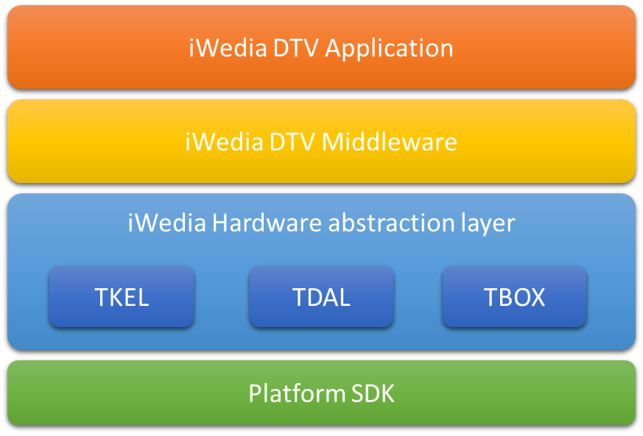
The following HAL modules must be developed on the chipset driver software:
- TBOX: It is the toolbox part. Its purpose is to declare some helpful functions and macros, in order to log messages, measure times, etc.
- TKEL: It is an abstract layer for the runtime operation system
- TDAL: It is the abstract layer for the driver. Each functional zone (audio/video, osd, demux, tuner, etc.) is covered by one module.
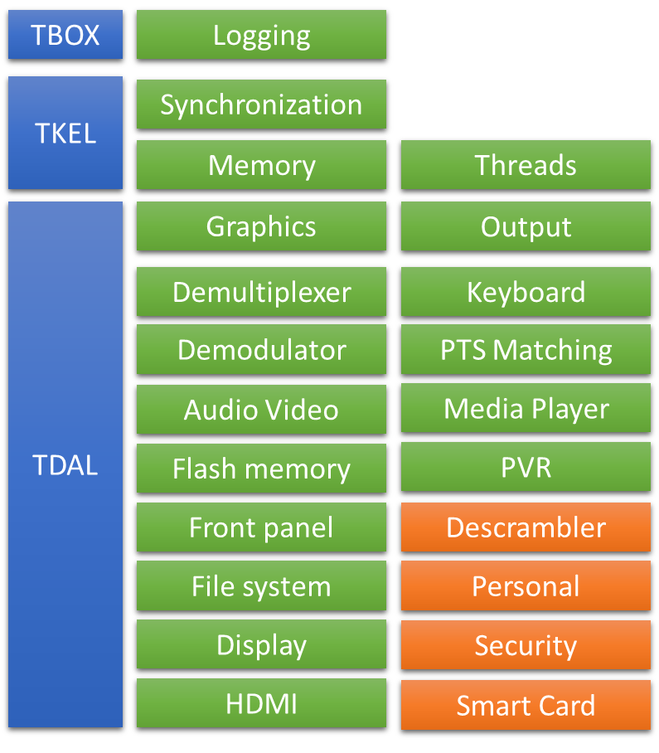

HAL Modules

TBOX (Tool box)
TBOX is the toolbox module. It is used to add debug traces into the code and to get input from user for test applications.
It contains a set of macros used to equip in the code:
- mTBOX_SET_MODULE: at the begin of each file to indicate the module concerned
- mTBOX_FCT_ENTER: at the begin of the function
- mTBOX_RETURN: replace normal calls to return
- mTBOX_TRACE: output made of format string and variable number of arguments, associated to module and level (bitmask):
- mTBOX_INIT_MOD_TRACE: to be called at initialization to activate logs of given module and levels
- mTBOX_PRINT: systematic output
- mTBOX_ASSERT: if given value is not correct then print error message
Some macros are also defined to get input:
- mTBOX_GETCHAR
- mTBOX_GETSTRING

The traces are included only if the TRACE is defined in the line of the compilation (e.g. –DTRACE=1). TRACE can take two values:
- 1: output /input are made on the default port (For example, it could be the debugging JTAG port of a platform).
- UART: output/input are made on the serial port.
User API allows to define a level of trace to debug and trace all traces, or critical traces only.

(Refer to the TBOX Specifications [2] document)

TKEL (Thin Kernel Layer)
TKEL provide an OS independent kernel abstraction (example: OS20, OS21, eCos, Linux, …).
It covers the following API for:
- Processes and task management: the task API in TKEL
- Synchronization tools: mutex, semaphores
- Critical sections
- Communication tools: queue API
- Memory management: a TKEL_Malloc and a TKEL_Free function.
- Timer management: set up timer event or timer callback
- API contains a transversal notion of event, that can be sent between the TKEL tasks. These events can also be used to received queues event, or to receive timer event.
TKEL is only used by the iWedia DTV and should not be used by the TDAL modules (they call the OS directly).
(Refer to the TKEL Specifications [1] document)

TDAL (Thin Driver Abstraction Layer)
TDAL is the driver abstract layer. This API is obviously the widest. It covers all the modules needed by IWedia DTV. These modules define an API for each functionality found in a DVB/MPEG product (STB and DRTV) and an IDTV product supported by IWedia DTV libraries.

Modules list
The table below lists the TDAL modules and a short description:
TDAL module | Description
TDAL_AV | It is the interface to control the audio/video. It Offers many functionalities, of which : display still picture, play audio sample or beep sound, play live video and audio, subscription to audio/video events, control of audio volume, audio mute, video scaling, video freeze, management of video aspect ratio.
TDAL_AVS | It is the layer to control the video/audio format. The drivers are used to control and route several signals coming either from internal decoder or external peripherals (VCR, TV).
TDAL_DMX | It is the layer to access the demultiplexer for section and PES filtering. The driver API provides a set of functions for demultiplexing digital television streams.
TDAL_COMMON | It contains the specific driver initialisation. It offers other useful API like a hard reset or a jump for the bootloader.
TDAL_DMD | It is the module for the Front End (demodulator). It allows to start a tuning or a scanning, handles the front end states and notify the client.
TDAL_FLA | This module describes the functions used to access Flash non-volatile memory. Refer to the manufacturer’s data sheet for a complete explanation.
TDAL_NVM | This module allows access to a non-volatile memory device (NVRAM) such as EEPROM device. It can emulate a non-volatile memory device in a flash block device if no NVRAM present in the system.
TDAL_GFX | This is the graphic interface. Its functionalities are the graphic region management, the palette management, the transparency management, the bitmap drawing.
TDAL_KBD AND TDAL_FP | This is the interface to manage the keyboard inputs from remote control (Keyboard) and the module to access to the Front Panel.
TDAL_TS | This module is the interface to manage transport stream routing, producing and consuming stages of a set-top-box especially in a PVR context. In a non PVR context, only a minimal implementation of TDAL_TS is needed.
TDAL_VBI | It is the layer interface for the Teletext VBI (Vertical Blanking Insertion).
TDAL_UART | This module is the standard serial port. It manages the traces on the serial port if needed.
TDAL_PTSM | It is the interface for the Presentation Time Stamp Module.
TDAL_OUTPUT | The aim of this module is to provide a complete interface between middleware and the video output stage low level driver of a set-top-box.
TDAL_DISP | The aim of this module is to provide a complete interface between middleware and the video display output stage low level driver of a set-top-box.
TDAL_FS | The aim of this module is to provide a complete interface between middleware and the content of storage media. Media can be hard disk or memory key plugged on IDE interface or via USB.
TDAL_CI | The aim of this module is to control Common Interface driver of the product. (DVB-CI and DVB-CI plus software)
TDAL_SEC | The aim of this module is to provide a complete interface between middleware and the security low level driver of a set-top-box (CI Plus software)
TDAL_SMC | The aim of this module is to control the smartcard driver of the product. (CA software)
TDAL_DESC | The aim of this module is to control the descrambler of the product. (CA and CI plus software)
TDAL_CRYPT | The aim of this module is to provide an interface with hardware secured crypto algorithms (secured CA software)
TDAL_RPC | The aim of this module is to provide a complete interface between IWedia DTV DRTV product (aka OBM) which implements the remote procedures call (RPC) being able to be called via the protocol OBM and the Analogue TV (ATV) client application who call these procedures. (DRTV product)
TDAL_SSU | The aim of this module is to provide a complete interface for system software update.
TDAL_HDMI | This module implements the HDMI protocol which implicates high level information management. It allows the application to have a video and audio output through the HDMI interface. It provides also a software API to configure some information needed by HDMI protocol. (STB software)
TDAL_HDMI_IN | This module implements the HDMI protocol which implicates high level information management. It allows the application to have a video and audio input through the HDMI interface. (IDTV software)
TDAL_HDMI_CEC | This module provides a complete interface to exchange CEC messages with other HDMI CEC equipment
TDAL_SCART_INPUT | This module provides an interface to manage the TV analog inputs for a SCART socket (IDTV software)
TDAL_SPEAKERS | This module provides an interface to manage the audio outputs through the TV speakers (IDTV software)
TDAL_PANEL | This module provides an interface to manage the video post processing of the TV panel (IDTV software)
TDAL_VBI_SLICER | This module provides an interface to manage the slicing of VBI data from an analog video source (IDTV software)
TDAL_ANA_INPUT | This module provides an interface to manage the audio/video analog inputs acting as an analog source selector (IDTV software)
TDAL_ANA_VID | This module provides an interface to manage the video analog inputs acting as a decoder (IDTV software)
TDAL_ANA_AUD | This module provides an interface to manage the audio analog inputs acting as a decoder (IDTV software)
There are two TDAL global revisions v1.0 and v2.0.
The v2.0 was created to allow the control of high definition multi-stream decoding/outputting new platform capabilities (such as PIP/PAP functionality, PVR) and a complete IDTV platform (analog part).
The table below lists the TDAL modules and their status in each revision and their presence in the different IWedia DTV products (STB / DRTV / IDTV).
Some of the TDALs are optional depending of add-ons: PVR, embedded CA, DVB-CI stack, …

TDAL module | v1.0 | v2.0 | STB | DRTV | IDTV
TDAL_ATA  TDAL_AV  TDAL_AVS  TDAL_CI  TDAL_COMMON  TDAL_CRYPT  TDAL_DENC  TDAL_DESC  TDAL_DMD  TDAL_DMX  TDAL_FLA  TDAL_FP  TDAL_FS  TDAL_GFX  TDAL_HDMI  TDAL_KBD  TDAL_NVM  TDAL_PTSM  TDAL_RPC  TDAL_SEC  TDAL_SMC  TDAL_SSU  TDAL_TS  TDAL_TSIN  TDAL_TSOUT  TDAL_UART  TDAL_VBI  TDAL_DISP  TDAL_OUTPUT  TDAL_ANA_INPUT  TDAL_ANA_AUD  TDAL_ANA_VID  TDAL_VBI_SLICER  TDAL_SPEAKERS  TDAL_PANEL  TDAL_HDMI_IN  TDAL_HDMI_CEC  TDAL_SCART_INPUT | X  X  X  X  X  X  X  X  X  X  X  X  X  X  X  X  X  X  X  -  X  -  X  X  X  X  X  -  -  -  -  -  -  -  -  -  -  - | Removed  Updated  X  Updated  X  X  Removed  X  X  Updated  X  X  X  X  X  X  X  X  X  X  X  X  X  Removed  Removed  X  X  Added  Added  Added  Added  Added  Added  Added  Added  Added  Added  Added | -  X  X  Opt  X  Opt  -  Opt  X  X  X  X  Opt  X  Opt  X  X  X  -  Opt  Opt  X  X  -  -  X  X  X  X  -  -  -  -  -  -  -  X  - | -  X  -  X  X  Opt  -  Opt  X  X  X  X  Opt  X  -  X  X  X  X  Opt  Opt  X  X  -  -  X  X  X  X  -  -  -  -  -  -  -  X  - | -  X  -  X  X  Opt  -  Opt  X  X  X  X  Opt  X  -  X  X  X  -  Opt  Opt  X  X  -  -  X  -  X  X  X  X  X  X  X  X  X  X  X

For new TDAL development, it is MANDATORY to implement TDAL v2.0: the STB/DRTV/IDTV columns are relevant only for HAL V2.0.

IMPORTANT NOTE on tdal_tsin and tdal_ts module:
For historical reason, some previous iWedia DTV products still rely on TDAL_TS module. Now iWedia DTV stack uses tdal_ts which provides the same functionality as tdal_tsin. For new TDAL development, it implies to develop tdal_ts module and no more tdal_tsin module.

Decode workflow for STB and DRTV

In following picture, it is presented logically how modules will be used in order to present picture to the user from TV source.
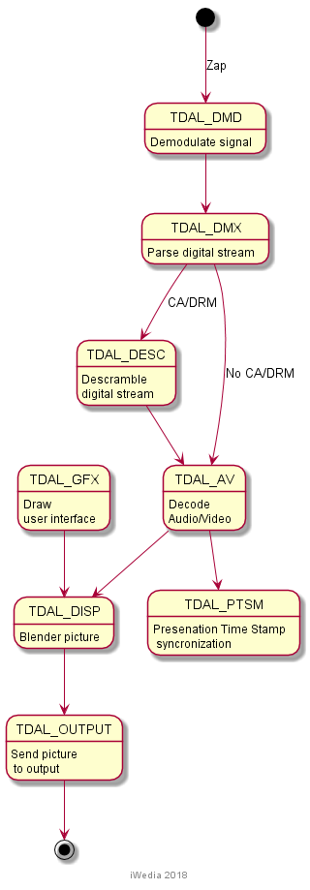
Figure 1 Zap workflow

Depending on the type of service, it may happen that digital stream has to be descrambled in which case TDAL_DESC module will be used to set hardware descrambling.

Decode workflow for IDTV
In case of digital TV sets, it is necessary to add additional modules that will control additional TV specific hardware (speakers, display panel). Picture below presents decoding workflow for such case

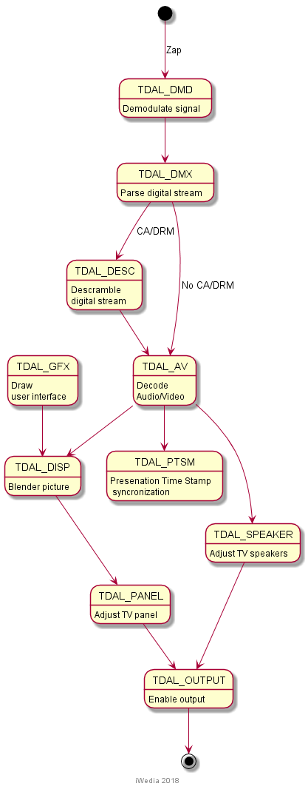
Figure 2 Decode Workflow for IDTV

Decode workflow with PVR recording
Here it is presented how modules interact when PVR recording is started along with active service being watched.
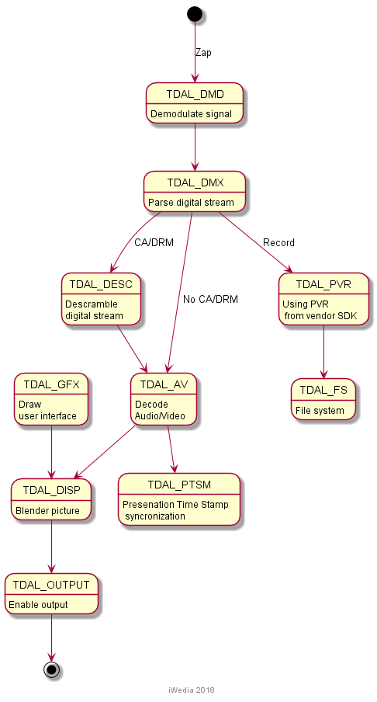
Figure 3 Decoding while recording content

Decode workflow in PVR playback
Here it is presented how modules interact when PVR recording is started along with active service being watched.

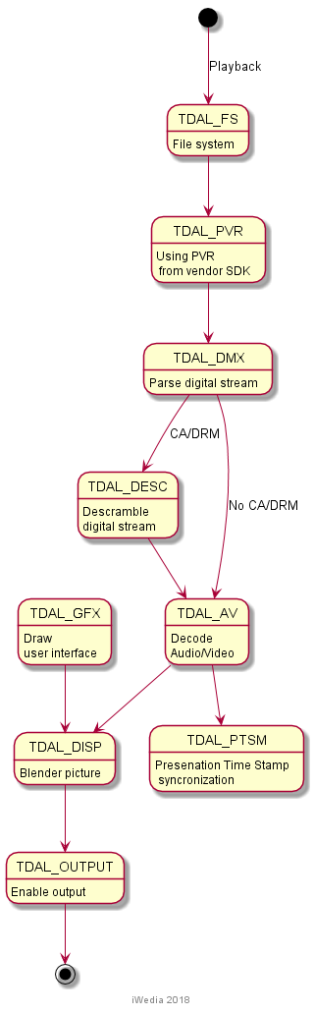

Development process for STB
The next picture gives the order of TDAL porting by modules. Stages and steps are described in more detail in Chapter 5.
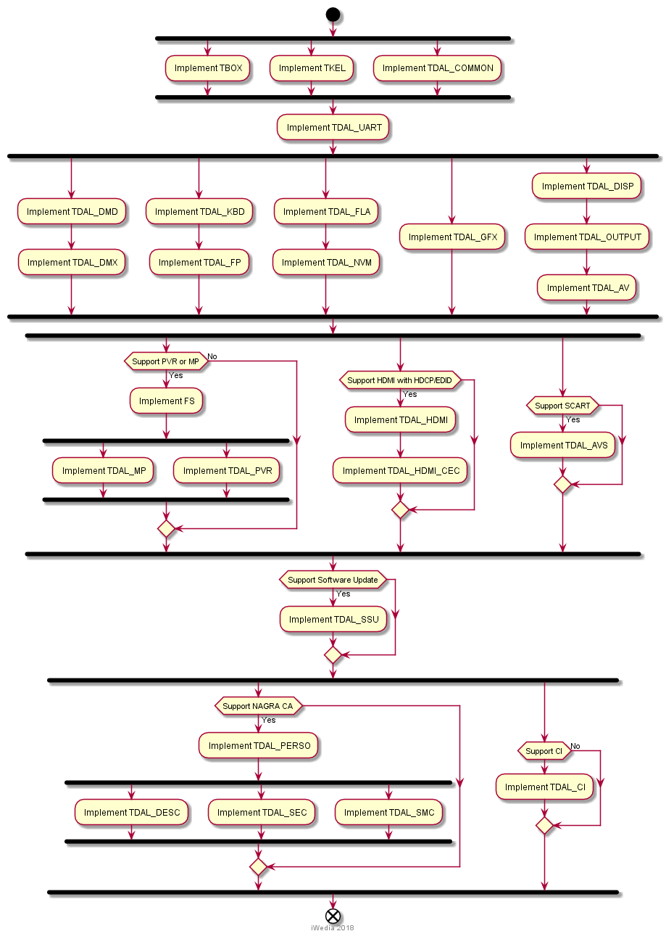
Figure 4 Devepomet stages and steps for HAL porting in case of STB

Development process for IDTV
The next picture gives the order of TDAL porting by modules. Stages and steps are described in more detail in Chapter 5. Compared to Figure 4 following diagram has additional modules related to TV sets (speakers and display panel) and input modules (SCART, HDMI and Analog inputs).
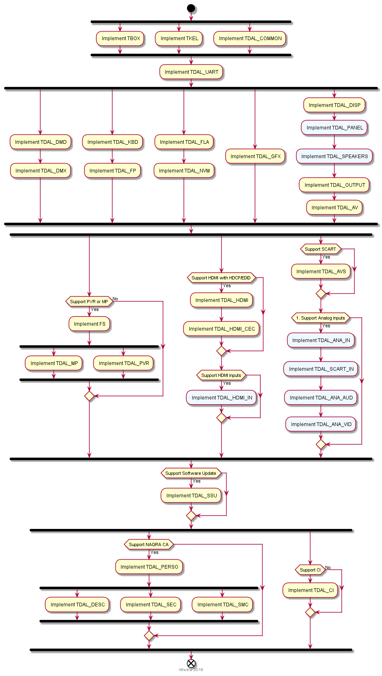
Figure 5 Devepomet stages and steps for HAL porting in case of IDTV

Development prerequisites
To start developing HAL, required items are:
- Target platform tool-chain
- Platform SDK
- Build tree
First two items are delivered by either device manufacturer or chip vendor. Third item is delivered by iWedia. Build tree is complete package necessary to develop and maintain HAL during its lifecycle. It contains:
- HAL documentation
- Build structure
- HAL API header files
- HAL reference code (optional)
- HAL validator package
- iWedia applications
- Third-party libraries (Conditional access system, digital rights menagment system)
Separate document deals with all details related to build tree and how to add platform SDK into it.

Porting Steps

Introduction
This chapter describes the different steps to develop your HAL.

Plan
There is an order you are advised to follow, in order to develop you HAL:
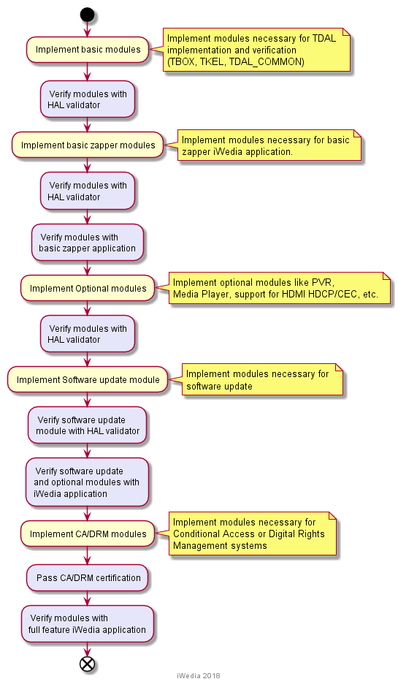
Figure 6 Stages in HAL developement
Pre-requisite is to adapt makefiles in order to compile, produce libraries and HAL validator. This step is fully covered in document explaining build tree.
First stage is to have a TBOX header with proper traces, useful to see what happens during development. Along with that TKEL should be implemented to have all the synchronization and memory allocation API available. Also TDAL_COMMON is required to be implemented in order to have synchronization and memory allocation API available for TDAL modules.
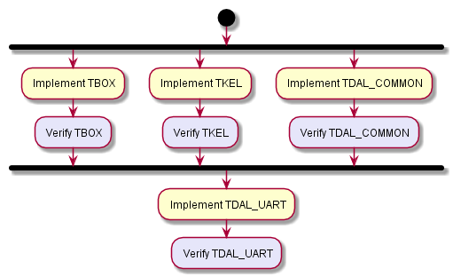
It should be noted here that TKEL is used only by iWedia application, and not by any of the TDAL modules. They use TDAL_COMMON API counter parts. If communication is only available using serial port, then additional TDAL_UART should be implemented, to support serial communication.

Develop the TDAL modules
The suggested plan to develop module is to start with the most independent modules, and to complete with the ones that requires others modules to be tested properly.

The module initialization
An important thing to note is the module initialization aspect.
On some platforms, drivers are initialized at boot time, by the kernel and module configurations. In this case, most of the TDAL_xxx_Init function can be empty, or simply implements a code to initialize necessary utilitary data.
On other platforms, drivers are not initialized. It is the responsibility of the module to set up corresponding chips correctly. In this case, it can be a good idea to implement first all the TDAL_xxx_Init and TDAL_xxx_Terminate to set up the whole platform.

Development stages
Modules in HAL can be separated in three groups, standalone modules and depedent modules. Standalone modules don't require other TDAL modules to be tested. They can be developed simultaneously. Dependent modules are those which require only other modules to be tested, eith just standalone modules or other dependent modules. For reference, here are standalone modules:
- The UART: it could be the first one to be implemented, if it is a required output for traces.
- The DMD/TS: the demodulator and TS routing are useful for many other tests, and particularly the DMX and AV modules.
Note: In IWedia DTV porting environment, the TS module has got different level of implementation depending of the PVR functionality present or not in the product.
- The DISPLAY/OUTPUT/HDMI: the display control and the digital encoder specifies the output encoding signal.
- The HDMI_CEC: this module allows CEC messages exchanges with other CEC equipments.
- The AVS: this module allows to route video/audio signal from digital encoders.
- The KBD/FP: these modules can be implemented alone
- The CI/DESC/SEC: the DVB-CI common interface and/or CI Plus TDALs can be implemented alone.
- The FLA/NVM: these two modules can be implemented together. They are all about non volatile memory.
Dependent modules are:
- The GFX: the OSD requires DENC and AVS to have proper output on TV screen. This module does not require AV.
- The DMX: the DMX requires DMD to have a signal and TS to have input stream.
- The AV: Audio/Video modules, which requires DMD, DMX, DISP, OUTPUT, AVS and TS to be properly tested.
In order to ease development dependency, development workflows were made as depected in Figure 4 and in Figure 5. Here we will explain them in more depth.
Once we have initial modules ready (TBOX, TKEL) and implemented TDAL_COMMON, second stage can be implemented. Goal is to implement only modules that will support basic zapper application. It means that keyboard modules, audio/video and graphics modules, as well as storage memory modules should be implemented. In Figure 7 process of developing and testing required module is give.
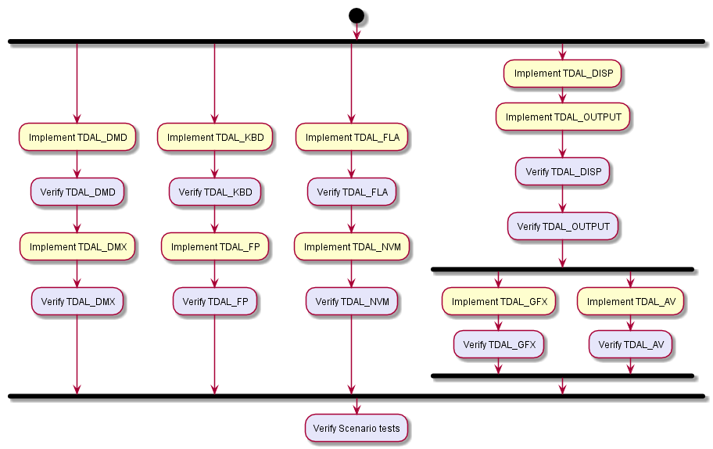
Figure 7 Basic modules stage
After all modules are implemented from this stage and verified using HAL validator unitary tests, next step is to test various scenario cases, like zapping, and testing graphics and video together. Purpose of those tests is to check usual cases with basic application before integration.
Next stage is to implement modules that are not essential but required to support additional feature like PVR, media player, or some specifics about HDMI or SCART.
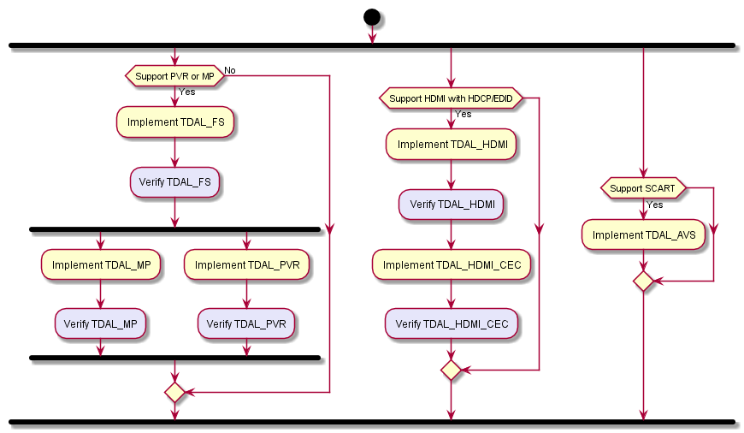
Figure 8 Optional modules stage
Next stage is supporting software update module. This stage could be done in parallel with prevous stage, but it is added as seprate because this module is mandatory for any iWedia application.
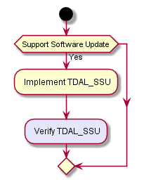
Figure 9 Software update stage
It should be noted that testing of this module is possible using HAL validator. Also this stage has to be testing using iWedia application supporting software update.
Finally, in order to support conditional access systems (CAS) or digital rights menagment systems (DRMS), it is necessary to implement specialized modules that are unique for the specific CAS/DRMS.
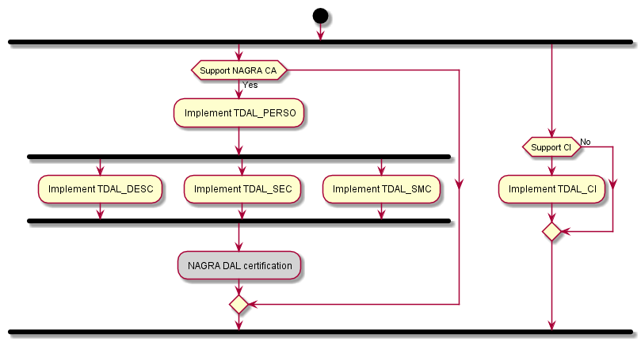
Figure 10 CAS/DRMS stage
In case of NAGRA CAS, it is necessary to pass NAGRA DAL certification, in order to verify modules related to it. Test suite is delivered by NAGRA, and iWedia provides application that will be linked with HAL in order to produce executable suitable for certification. For details check document describing build tree.
In case IDTV is being developed additional modules have to be implemented, so basic module stage and optional module stage are extending with additional steps as given in following figures.
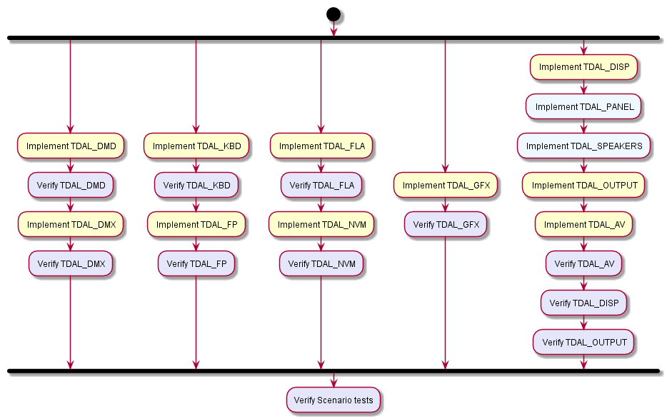
Figure 11 Basic modules stage
As seen in the Figure 11 additional basic modules are TDAL_SPEAKERS and TDAL_PANEL.
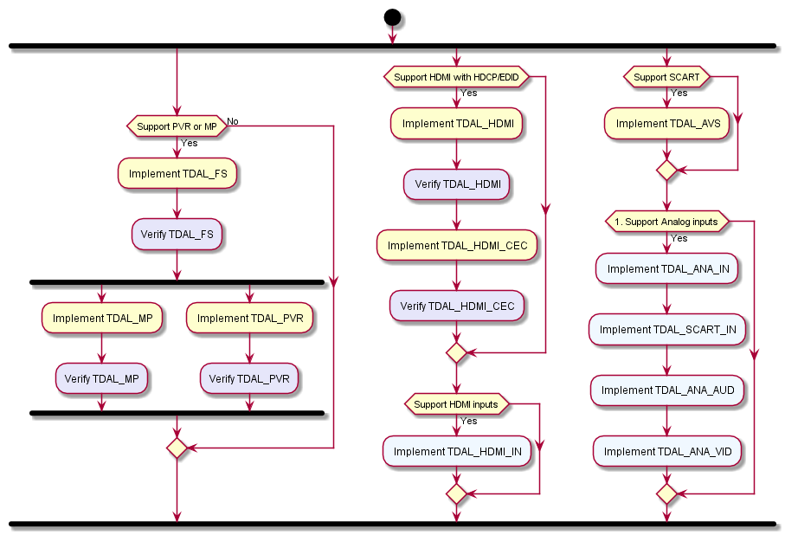
Figure 12 Optional modules stage
For optional modules in case of IDTV, it is necessary to add modules related to digital input (TDAL_HDMI_IN) and analog input (TDAL_ANA_IN, TDAL_ANA_AUD, TDAL_ANA_VID, TDAL_SCART_IN).

Validation

HAL validator test framework
Each step of development can be validated with the HAL validator product. There is a document describing the test manager framework (refer to the Test Manager [3] document).
After makefiles adaptation, the HAL validator can be executed. Its verbose execution gives test results of each modules of the HAL.

Test along the development
All along the development, HAL validator can be used to validate each part. The test root can be changed in order to see only the tests that are interesting for the actual development.
In prevous chapter, it is pointed what set of test should be executed at each stage for each module.
Note: HAL validator contains tests that require live signal input. Validator is configured to use specific streams, which are delivered as part of HAL validator package, but it is also possible to change configuration and use arbitrary streams.

Final test
The final test consists in executing the whole test tree, interactively (using Test Manager [3]). It is necessary that all tests pass after all modules are implemented.

Conclusion
As said in the introduction, this document is the « overview » document, to help you start to port HAL on a new platform in the best way.

